Applicant Dashboard Access
To access the dashboard please follow the link below
Home - ESR Hub - NHS Electronic Staff Record
This will load the ESR home Page
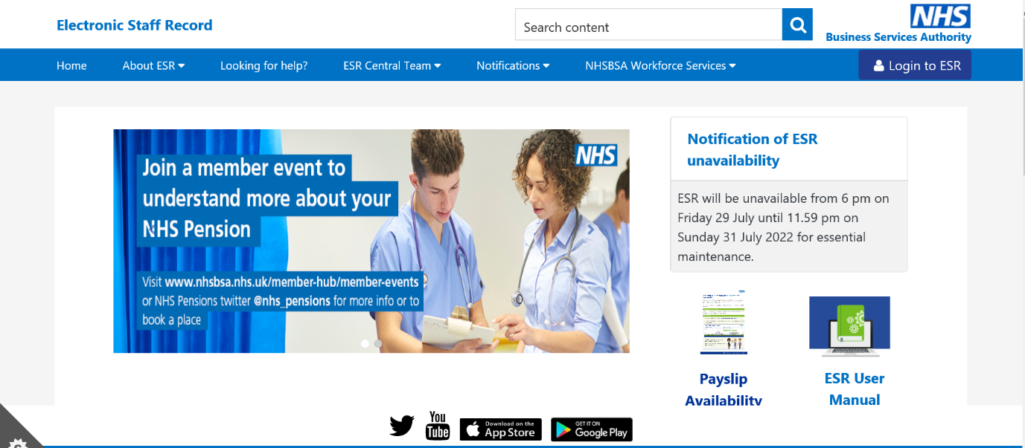
Select the Log in to ESR button on the top right
Here you will need to enter your personal email address in the username field and then select Forgotten |Request Username/ Password | Unlock Account
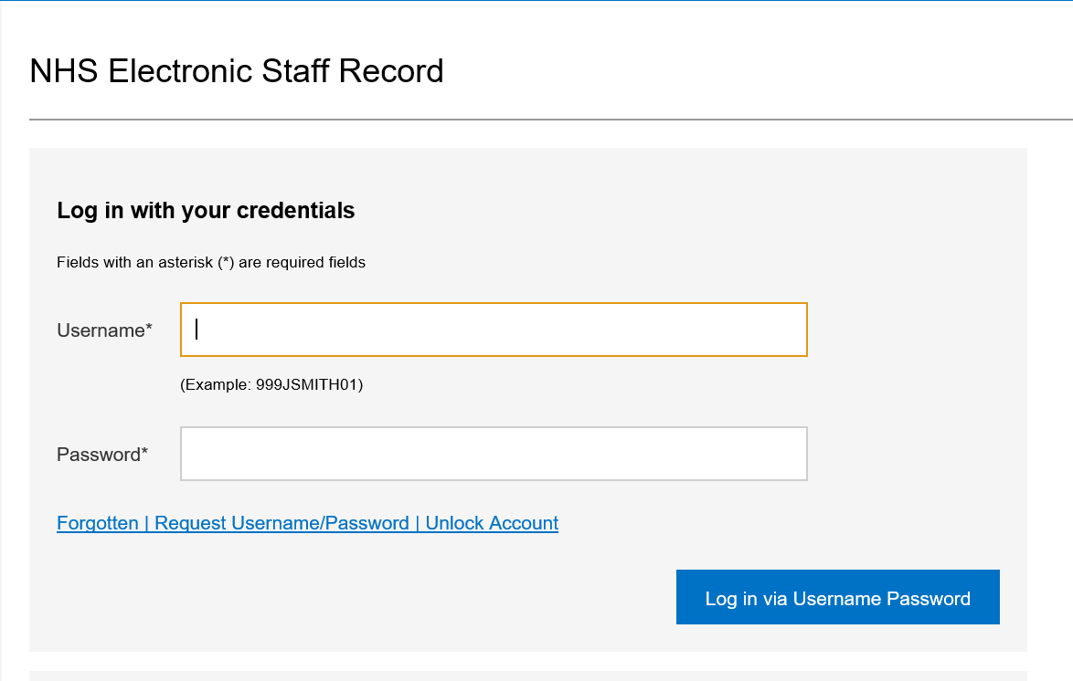

You will be sent a link to reset your password. Once you have reset the password return to the page and you will be able to log into your ESR Applicant Dashboard
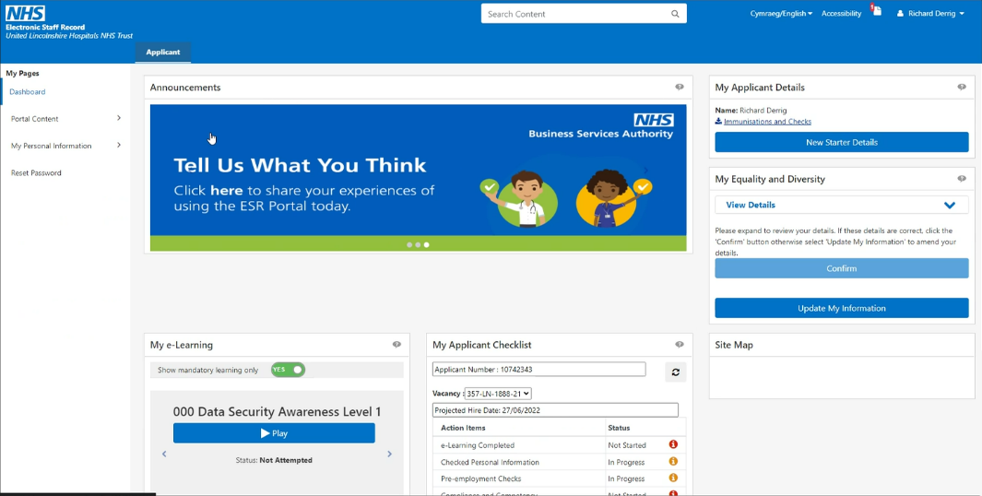
Once logged in you will see the page below.

You will be able to review your application details as well as reviewing your applicant Checklist. You will also be able to start your Mandatory training. This can be found under the My e-Learning section.
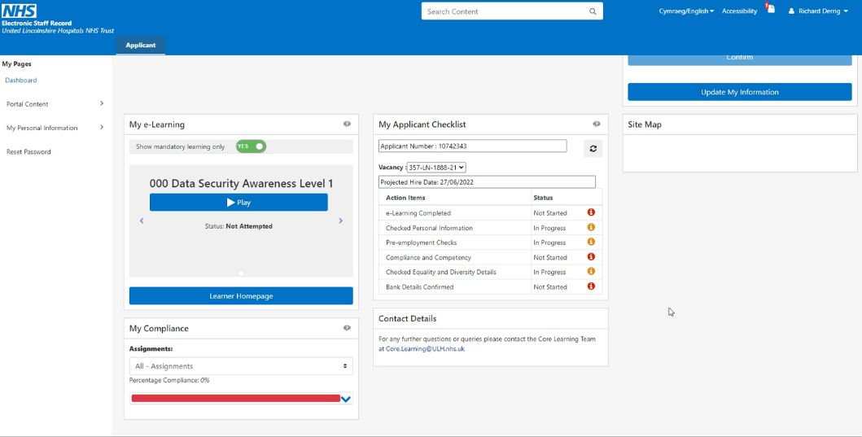

To start the e-Learning process select the Learner Home Page button shown above

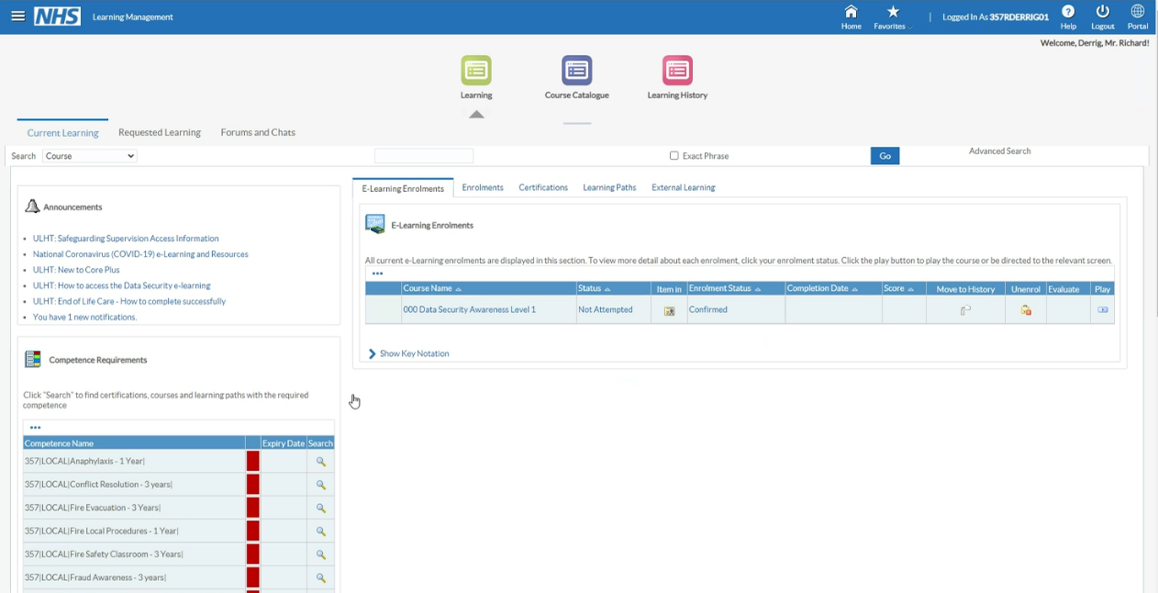
This will take you to your learner home page, this will show the learning requirements that are attached to your role on the left hand side, they will be showing as Red as they are yet to be completed

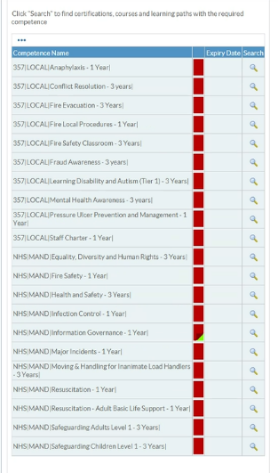
To access the training you will need to select the magnifying glass at the side of the training course

This will be you to the course detail page shown below, next you will need to select the details tab
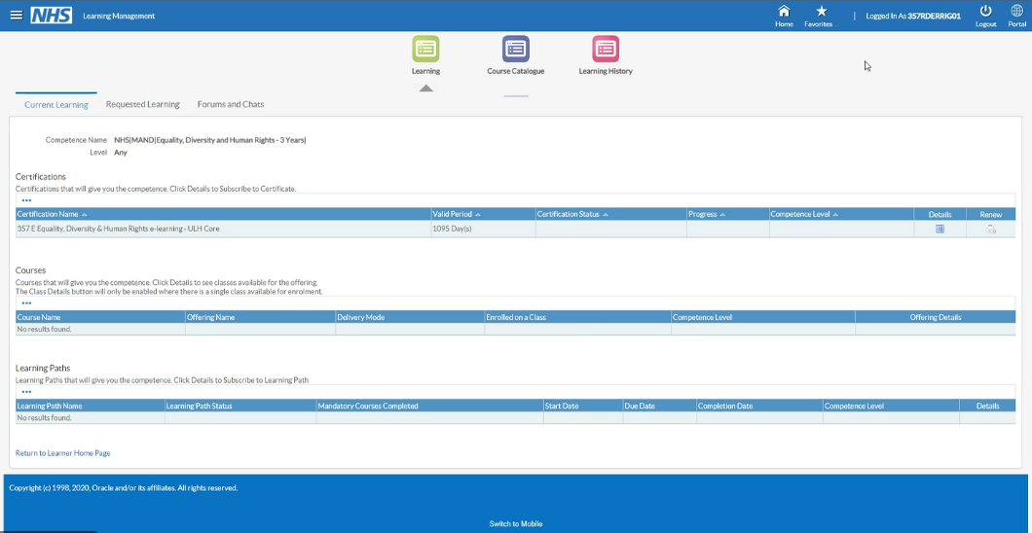

Then Subscribe to the course
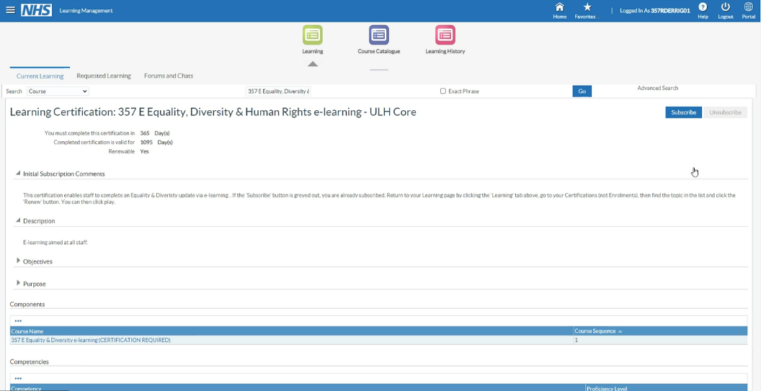

Then Finish
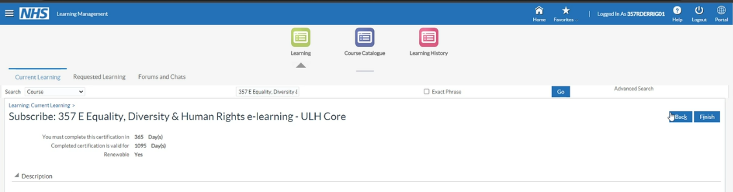

Finally you will need to select Enrol
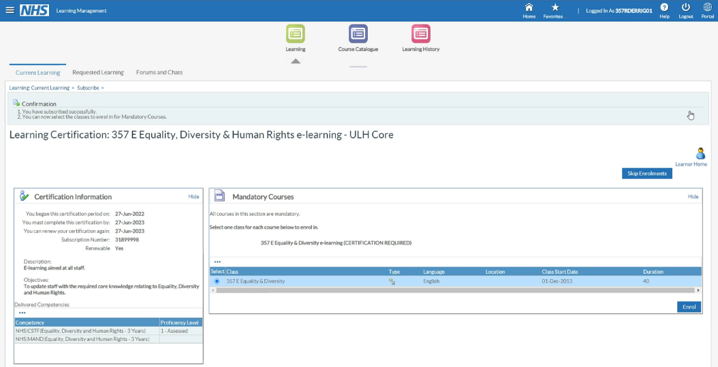

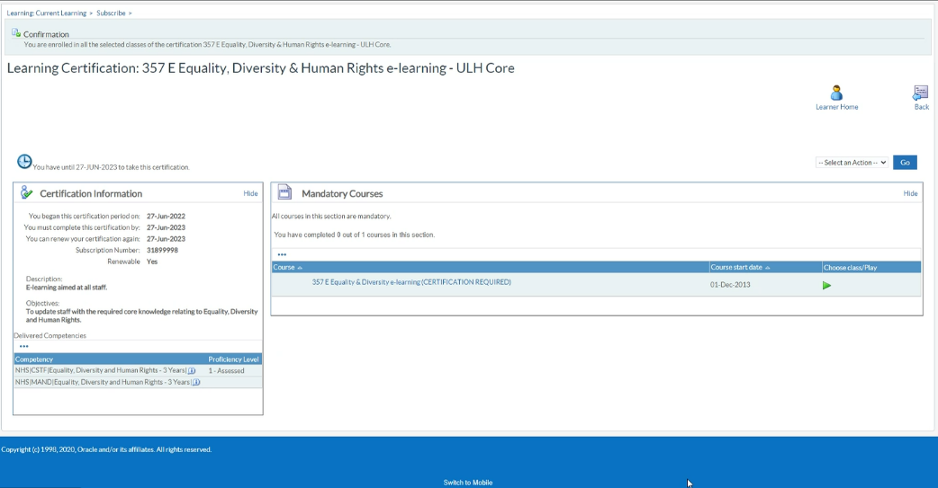
You will then be able to play the training by selecting the play button

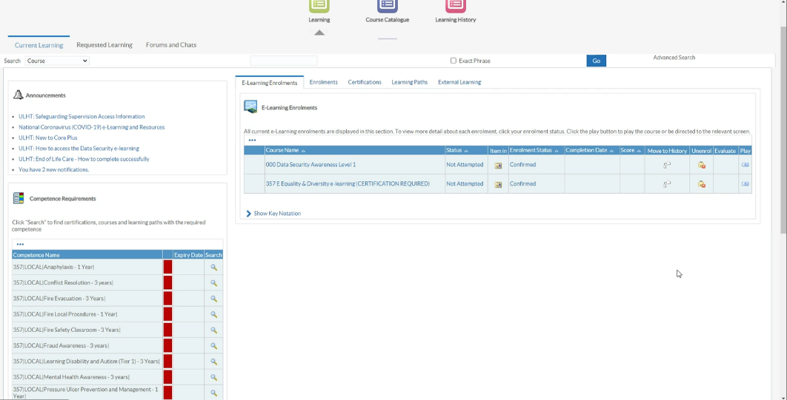
If you are unable, to complete the training this will show on your Learner Home Page and you can access it from there

