
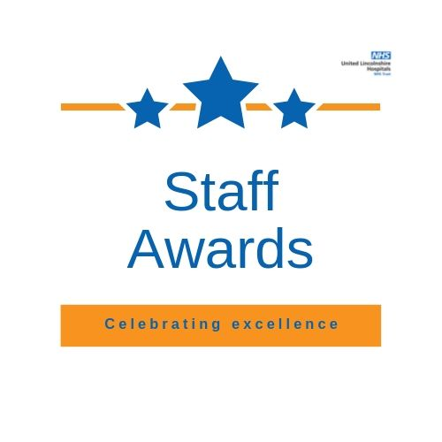
Categories and criteria
Award Category | Details | Criteria
Great Patient Experience Award | We only receive patient and public nominations for this award.  Patient representatives carry out the longlisting for this award, and a patient rep is on the shortlisting panel. | The team or individual that has made a significant impact upon improving the patient experience either for an individual patient, in their work area or for the Trust as a whole. This can be judged by feedback or complaints from patients and data.  The judges will be looking for evidence of:  - A positive impact on patient experience or patient safety.  - How teams or individuals used information or feedback to improve the patient experience or patient safety.  - Teams or individuals who have demonstrated ways in which they have championed and improved the quality and safety of patient care.  - Teams or individuals who uphold the Trust values.
Compassion and Respect Award | This award is nominated by staff and patients and longlisted along with the others. The final winners and highly commended entries are chosen from the shortlist by the Trust Chair, against the following criteria. | An individual or team that shows a genuine concern and compassion for others, is interested in others and in helping to meet their needs and providing the best possible quality of care. They treat people as valued individuals and strive to put the needs of others before their own, taking into account principles of equality and inclusion.  The judges will be looking for evidence of:  - How, or why, this person or team has special qualities, cares about others and understands what each individual needs.  - How they champion dignity and respect, treating others how they wish to be treated and promoting equality and inclusion for service outcomes.  - A positive impact on patients, carers or staff.  - Teams or individuals who uphold the Trust values.
Team of the Year- Clinical |  | A clinical team who consistently demonstrate good team working, to deliver an efficient and high performing service. They have successfully implemented change and/or improved services for the benefit of their patients, taking into account the quality and safety of the care they provide..  The judges will be looking for evidence of:  - Effective teamwork and collaboration.  - Teams working together to support personal and professional development of members.  - Improvement work that has taken place on behalf of patients.  - Evidence of high quality services and upholding the Trust values.
Team of the Year- Non-Clinical |  | A non-clinical team who consistently demonstrate good team working, to deliver an efficient and high performing service. They have successfully implemented change and/or improved services. This could include developing new ways of working and shared learning.  The judges will be looking for evidence of:  - Effective teamwork and collaboration.  - Teams working together to support personal and professional development of members.  - A flexible approach by team members.  - Evidence of high quality support services and upholding the Trust values.
Service Improvement, Education and Research Award |  | The team/individual who have developed or undertaken service/quality improvement (perhaps through the Quality Improvement Programme), made changes to the way they work, made savings, research, education or training for the benefit of patients, the department and the Trust as a whole. This may include implementing an idea or innovative approach which has resulted in improved practice, a new way of working or a saving of time or money. It may also include individual development through education or training, for the benefit of their patients. They may have carried out or published innovative research papers or been involved with clinical trials.  The judges will be looking for evidence of:  - Details of research, academic or personal development success.  - The team or individual identifying areas which could be improved, or made more efficient and effective using an innovative approach.  - Improved services, for example through quality improvement or monitoring of outcomes for staff or patients.
Unsung Heroes- Clinical |  | An individual working in a clinical role who has made an exceptional contribution to the Trust and its services, but whose contribution and role often goes unrecognised. They show dedication and commitment to their role and make a genuine difference to others.  The judges will be looking for evidence of:  - Compassion and concern being shown for the wellbeing of patients, carers or colleagues.  - The individual being a valued member of their team. Listening and involving patients, carers or colleagues, helping them make choices and contribute.  - The individual’s special qualities and contribution not being recognised as much as they should.  - Teams or individuals who uphold the Trust values.
Unsung Heroes- Non-Clinical |  | An individual working in a non-clinical role who has made an exceptional contribution to the Trust and its services but whose contribution and role often goes unrecognised. They show dedication and commitment to their role supporting clinical services, and make a genuine difference to others.  The judges will be looking for evidence of:  - The individual doing their bit to support the work of the Trust as a whole.  - Compassion and concern being shown for the wellbeing of everyone.  - The individual being a valued member of their team. Listening and involving everyone.  - The individual’s special qualities and contribution not being recognised as much as they should.  - Teams or individuals who uphold the Trust values.
Extra mile - Clinical |  | An individual or team working in clinical services that goes beyond their job description to help the Trust deliver its objectives and values. Bringing about change and clear benefits for patients, their colleagues and the Trust as a whole. They epitomise creative thinking, commitment, determination and drive.  The judges will be looking for evidence of:  - Excellence in customer service.  - A standard of service that consistently exceeds expectations.  - Demonstrable and sustainable improvements in patient care and safety.  - Dedication to quality improvements and efficiency in their service.  - Teams or individuals who uphold the Trust values.
Extra mile – Non-Clinical |  | An individual or team working in a non-clinical setting that goes beyond their job description to help the Trust deliver its objectives and values. Bringing about change and clear benefits for the Trust as a whole. They epitomise creative thinking, commitment, determination and drive.  The judges will be looking for evidence of:  - Excellence in customer service.  - A standard of service that consistently exceeds expectations.  - Demonstrable and sustainable improvements which contribute to quality care and safety.  - Dedication to quality improvements and efficiency in their service.  - Teams or individuals who uphold the Trust values.
Outstanding Leader Award |  | An individual with outstanding leadership skills who inspires people to go the extra mile. Good leaders are not necessarily managers. They are innovative and value their peers while actively mentoring and encouraging people they work with. Tireless in their efforts to change the system for the benefit of all.  The judges will be looking for evidence of:  - Excellent communication skills.  - An individual’s ability to inspire and motivate others to achieve objectives.  - How barriers to change have been overcome.  - How the individual has promoted equality and inclusion and promoted personal and professional development as part of support to their colleagues.  - Demonstrated how they uphold the Trust values.
Volunteer of the Year Award |  | An individual or team of volunteers who work tirelessly and generously give their free time, enthusiasm and energy to help improve NHS services, facilities and support for patients, visitors and their families.  The judges will be looking for evidence of:  - Significant impact of what they do on the people and service they support.  - How they have demonstrated a positive attitude, regularly contributing to the wider team.  - The individual or team being an exemplary role model for volunteering and upholding the Trust values.
Chief Executive’s Award | Nominations will not be taken for this award.  The winner will be chosen by the Trust Chief Executive to recognise a member of staff or team that deserves public recognition of their achievements over the last year.

