I need to take medication for my mental health during pregnancy – what does this mean when my baby is born?
- The reviews will include checking how alert your baby is and looking for any signs of irritability or distress, testing his/her movements for any stiffness or floppiness as a well as listening to the baby’s heart and lungs.

- The Healthcare Professional will also ask if you have any worries about your baby’s wellbeing, including how he/she is settling, feeding and sleeping.

- The check will take around 10 minutes and is not harmful or painful for your baby.

- During the check the Health Care Professional will talk to you about any concerns they find with your baby and whether these are due to medication or other causes. They will explain any investigations or treatment needed.

- If you are taking one medication in pregnancy your baby will be observed for 24 hours in hospital. If you are taking more than one medication in pregnancy, a referral will be made to the paediatrician and they will put a plan in place for your baby i.e. the length of time Health Care Professionals will observe your baby. Please note: You will not be seen by the paediatrician. Unfortunately home births are not available to you as your baby will require at least 24 hours of observations by a Health Care Professional.

- Many medications are safe to take while breastfeeding, the professionals involved with your care will work with you to find the most appropriate medication.

Women need to take medication for many different physical and mental health problems during pregnancy. You have been given this leaflet as you and your doctor decided that it would be safest for you to take medication for your mental health during pregnancy. This includes antidepressants, antipsychotics and anti-anxiety medications. Some babies can experience symptoms after birth because of these medicines. For this reason your baby will have observations following birth. You should not worry about this – even if babies do develop symptoms these usually settle down within a few days without the need for any treatment.

Do I need to do anything when I am pregnant?

- Make sure you tell the people involved in your care what medication you are taking.

- Do not stop or make changes to your medication without talking to your doctor first.

- Take medication regularly and make sure you do not run out – if this happens make sure you talk to your GP or Psychiatrist about what to do.
- Your doctor will tell you about any symptoms your baby might experience.

What about after my baby is born?

- If you give birth in hospital a Healthcare Professional will check your baby just after birth to make sure that he/she is not experiencing any physical health problems.

Who should I speak to if I’m worried about my baby’s health?
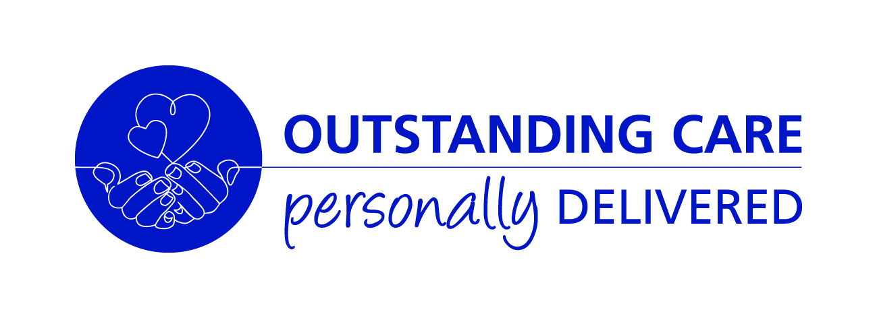

If you are worried about your baby, speak to your GP, midwife or health visitor.
If at any time your baby appears unwell, drowsy or has feeding difficulties you should see your GP or take him/her to A&E.
Baby information:
for mothers who take medication to support their mental health in pregnancy.

Maternity
ULHT
www.ulh.nhs.uk

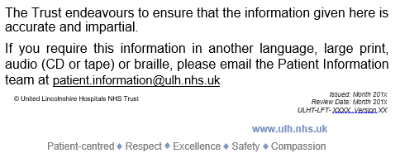
Further information about medications in pregnancy can be found at:
www.choiceandmedication.org/lpft
BUMPS (Best use of Medicines in Pregnancy):
www.medicinesinpregnancy.org/
Royal College of Psychiatrists: www.rcpsych.ac.uk/healthadvice/problemsdisorders/mentalhealthinpregnancy.aspx

