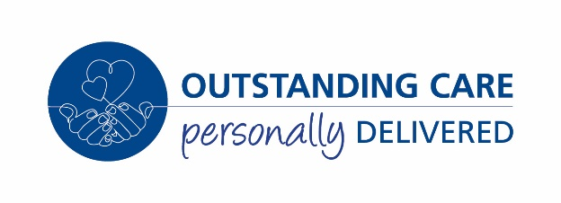
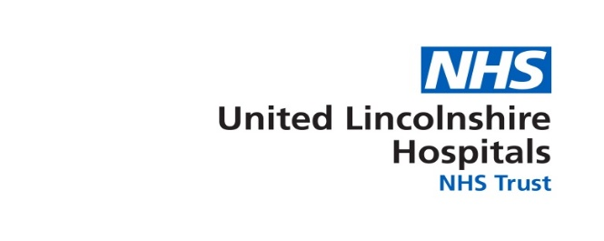

Trust Headquarters
Lincoln County Hospital
Greetwell Road
Lincoln
LN2 5QY

Tel: 01522 XXXX
www.ulh.nhs.uk

Dear XX

COVID-19 Restore Plan – Temporary change to working arrangements

As you are aware, as a Trust we are planning to temporarily create a largely COVID-free ‘Green’ site at Grantham and District Hospital to enable us to increase the elective activity that we can rovide, including transfer of chemotherapy, cancer surgery and other surgery from across Lincolnshire. To enable this all patients must have a known COVID-19 status on admission to any ward at Grantham, and therefore we will be temporarily changing the urgent care offer at the hospital from an A&E to an Urgent Treatment Centre (UTC) and transferring unplanned admissions to our other hospitals. This will take place from Monday 22 June.

This temporary change is part of the Trust’s response to the level 4 national emergency, and accordingly will be reviewed when the current phase of the response nationally ends. Based on current available information this will run to the end of March 2021 but could be subject to change. It will be reviewed quarterly throughout.

I spoke to you on <date> regarding the temporary changes needed to your working arrangements to support this plan. I confirmed that from <start date> you would <detail changes – location / hours / role>. We discussed the support you would need to enable this and we agreed / I am. <details of any support arrangements e.g. exploring options with HR, travel time, shorter shifts, change in working days etc>.

I appreciate that this is a challenging time and you may feel anxious about the changes. Support is available to you through myself, your Trade Union and through a range of support offers that are summarised below.

I would like to take the opportunity to thank-you for your commitment and support through the ongoing national emergency.

Yours sincerely
Line Manager
CC. COVID-HRenquiries@ULH.nhs.uht
