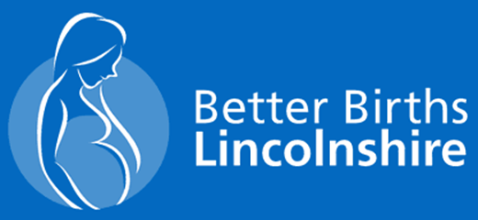 

**My Vision, My Choice, My Pregnancy**



Our work is enhancing the choices available in maternity services, building on this and helping Local Maternity & Neonatal Systems (LMNS) to deliver more choice and control for women and their families by providing a personalised approach to their maternity journey.

**Congratulations on your pregnancy**

Having a baby is a special time in your life.

Your local National Health Service (NHS) would like to make sure you receive the maternity care you want in the place you want wherever possible.

The aim of this booklet is to summarise the main options available to you in Lincolnshire following discovering that you are pregnant. It will hopefully help you decide your initial preferences of where you would like to birth your baby. Following this decision you will then be provided with access to a ‘**My Birth, My** **Journey, My Choice’** booklet which will provide a breadth of information and help you on your pregnancy journey.

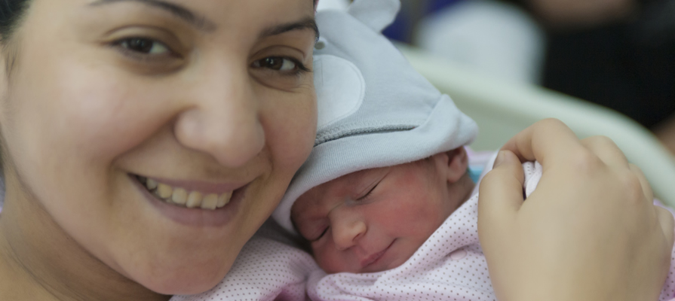

**Every pregnancy journey is different. Your maternity team is committed to supporting your individual needs.**

**Your Maternity Journey...**

**Weeks 0-12**

As soon as you know you are pregnant, it is recommended that all women take folic acid and Vitamin D supplements. Folic Acid tablets (400mcg daily) can be taken up to 12 weeks pregnant, but Vitamin D can be taken throughout pregnancy and whilst breastfeeding. For more information visit:

**NHS Choices**

[www.nhs.uk/conditions/pregnancy-and-baby/vitamins-minerals-supplements-pregnant/](http://www.nhs.uk/conditions/pregnancy-and-baby/vitamins-minerals-supplements-pregnant/)

You may be able to self-refer (online) to the hospital of your choice. Try searching [www.BetterBirthsLincolnshire.co.uk](http://www.BetterBirthsLincolnshire.co.uk). https://www.youtube.com/watch?v=Vb14OMe6D84

You should try to get your first ‘booking’ appointment before ten weeks.

**It is important at these early stages to keep healthy and happy ☺**

If you, or anyone in your household smokes, you will be offered support to stop smoking throughout your pregnancy. [**www.nhs.uk/common-health-questions/lifestyle/what-are-the-health-risks-of-smoking**](http://www.nhs.uk/common-health-questions/lifestyle/what-are-the-health-risks-of-smoking)

There are foods you should avoid when you are pregnant**, see:** [**www.nhs.uk/conditions/pregnancy-and-baby/foods-to-avoid-pregnant/**](http://www.nhs.uk/conditions/pregnancy-and-baby/foods-to-avoid-pregnant/)for the latest guidance. You may also be entitled to vouchers to help buyfruit, vegetables and milk, see**:** [**www.healthystart.nhs.uk/**](http://www.healthystart.nhs.uk/)and always check with your GP, pharmacist or midwife before you takeany medicines.

Visit **www.nhs.uk/start4life** for tips on keeping yourself well during pregnancy

Looking after your mental health is important too. Pregnancy is a joyous time, but can also be fraught with anxieties. Your GP, Midwife or practice nurse can advise and support you in this journey so please contact them if you feel additional help is required.

You will need to consider where you want to have your baby at home, or in a Hospital. It is important to start your antenatal care as soon as your pregnancy is confirmed so that you have the best opportunities and information to hand. You will have named midwives, who will co-ordinate your care with you and the professionals. You will be offered a range of appointments and tests throughout your pregnancy, some women may need more appointments or tests than others. Your antenatal care may be offered in a Children’s Centre or a GP Surgery or even at your home if you wish and your Midwife can accommodate this.

Studies (Sandall et al, 2016) show that maternity care, including the birth, provided by a midwife or team of midwives you know, leads to better outcomes and safety for you and your baby. Continuity of carer is being introduced and launched area by area which means that your maternity care will be given by a group of Midwives in the community whom will follow your pregnancy from the beginning right through to birth and beyond. The team will assist, support and introduce you to having the best pregnancy possible and it is hoped that by having a smaller team of Midwives helping you it will reduced any fears or anxieties you may be experiencing.



**Where to have your baby**

**Home birth**

Midwives come to your home to support you during your labour and birth.



Home births are recommended for women who have a low risk, straightforward pregnancy and want to birth in their own home with support from midwives and their families/friends.

The Birth Place Study (2011) reviewed 65,000 births in England of women who were low risk and had a straightforward uncomplicated pregnancy.

The research showed that, for second and subsequent babies, home births are just as safe as hospital births for the woman and her baby with a straightforward pregnancy. Home births can reduce the likelihood of needing a caesarean section.

Women having their first baby at home may have a slight difference in the outcome for their baby having a problem during or post-birth, however the overall risk is low: 9.3 adverse perinatal outcomes per 1000 planned home births compared to 5.3 per 1000 in planned obstetric births.

You will have 2 midwives with you whom are trained in emergency care relating to labour and birth and whom will be with you if the decision is required to transfer you to your local Maternity Unit for assistance.

**The Birth Place Study also showed:**

88% of women having a second or subsequent birth at home are likely to stay at home when in labour.

55% of women having their first baby at home are likely to stay at home when in labour.

Analgesia (pain relief) options include gas and air (Entonox), Paracetamol and a birthing pool.

Please speak to your midwife if you are considering a home birth.

**Reasons to consider a home birth**

* Safe birthing environment for women whose pregnancy is low risk
* You can enjoy the comforts of your own home to help you relax, help progress your labour naturally and enjoy a positive birth experience
* Minimises the need for medical intervention

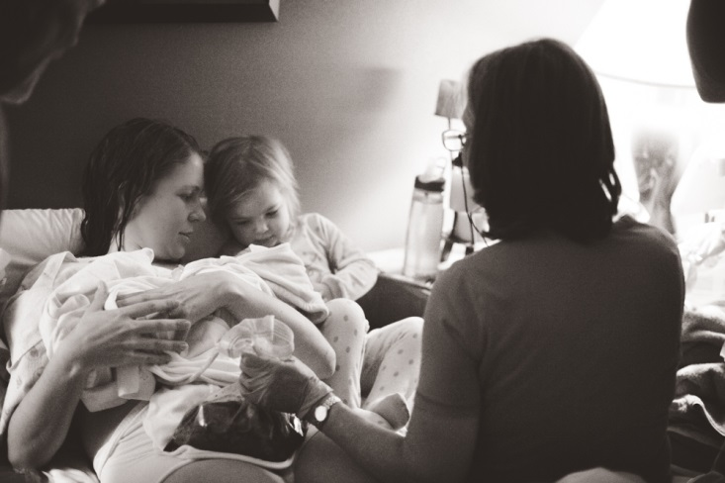

**Alongside Birth Centre**

An alongside birth centre is a ‘home from home’ birthing centre situated in a hospital and is in close proximity to the main obstetric unit. This setting is recommended to all women whose pregnancy is classed as low risk including first time mothers.

In labour you will be cared for by midwives and support staff and have access to the use of facilities and birthing aids which help promote natural birth which helps reduce the need for intervention. Women also have the option to birth their baby in a birthing pool. Analgesia options include birthing pools, which evidence shows may shorten your labour, make it less uncomfortable and gives a positive birth experience to women and their families. A TENS machine (trans-electrical nerve stimulation which triggers the release of the body’s own pain relief), gas and air (Entonox) and opiates (injection of Pethidine or Diamorphine).

The chances of you or your baby having a serious medical problem is the same for women planning to birth in a freestanding unit or delivery suite in an obstetric unit.

Women planning to birth their baby in an alongside birth centre are less likely to need medical intervention such as a caesarean section and episiotomy.

However if you or your baby were to need medical assistance this can be arranged immediately and transfer to the main delivery suite organised. You will be accompanied by your midwife throughout all of this.

**The Birth Place Study reports:**

60% of first time mothers stay on an alongside birth centre during labour.

87% of women having their second and/or subsequent baby stay on an alongside birth centre during labour.

Following the birth of your baby the midwife will help you to get ready to go home within a few hours. If you require a stay in hospital you will be transferred to the postnatal ward where your care will be continued. If you wish to birth your baby in an alongside birth centre please discuss this with your midwife.

**Reasons to consider an alongside birth centre:**

* Safe birthing environment for women whose pregnancy is low risk
* Home from home like unit
* Reduces the risk of requiring medical intervention in labour
* Opportunity for partners to be more involved

**12**

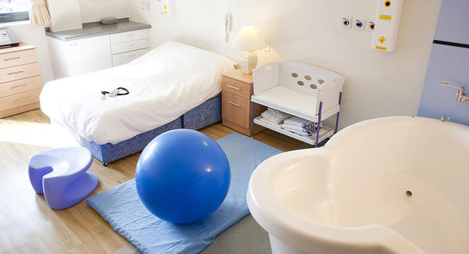

**Delivery suite (labour ward)**



Women who have experienced complications either during their current pregnancy or in a previous pregnancy will have discussions with their Obstetrician and Midwife regarding the best place to birth their baby. It may be recommended to birth their baby on a delivery suite/labour ward which is situated in a hospital. Care during birth is led by an obstetrician and provided by a team of midwives and doctors.

Women, whose pregnancy has been complicated, classed as high risk, are more likely to need extra monitoring and observations and/or require medical assistance and additional help during their labour and birth. Should your baby need additional assistance a neonatal team and unit is also on site where your baby can be cared for. A delivery suite also has dedicated maternity theatres should you require a planned or emergency caesarean section.

After the birth of your baby your care will be continued in hospital until you and your baby are well enough to return home.

Analgesia options include gas and air (Entonox) opiates (injection of pethidine or diamorphine), epidural, and birthing pools may be available in some delivery suites.

A delivery suite is located in a hospital in the maternity unit and a dedicated midwife will care for you throughout your labour and during your birth.

A team of obstetricians, anaesthetists and neonatologists are also on site to care for women and their babies who experience complications during birth.

For women whose pregnancy is straightforward and low risk, birthing your baby on a delivery suite may increase the likelihood of intervention during birth (Birth Place Study, 2011). However if this is where you would prefer to have your baby this will be supported by your Midwives and health professionals. In some instances women may want to choose or feel they ‘need’ and Elective Caesarean birth. There is a dedicated Birth Choices Clinic and access to a Consultant Midwife whom can assist in this discussion also.

**The Birth Place Study reports:**

More than three quarters of all low risk women with uncomplicated pregnancies, who planned to birth their baby in a midwife led setting had a ‘normal birth’ without medical interventions, compared with 58% of women in the obstetric unit group.

If you wish to birth your baby on a delivery suite please discuss this with your midwife.

**Reasons to consider birthing on a delivery suite:**

* If your pregnancy has been classed as complicated and high risk
* If you or your baby has a known medical condition and needs specialist care
* Personal choice
* You wish to have an epidural in labour



**Important Contact details for NHS Provider’s in Lincolnshire and the surrounding areas.**

**United Lincolnshire NHS Hospital Trust**

[**www.ulh.nhs.uk**](http://www.ulh.nhs.uk)

**Lincoln County Hospital**

Greetwell Road

Lincoln

Lincolnshire

LN2 5QY

(01522) 512512

Bardney Ward – Labour Ward

(01522) 573140

**Pilgrim Hospital Boston**

Sibsey Road

Boston

Lincolnshire

PE21 9QS

[(01205) 364801](tel:(01205)364801)

Labour Ward - (01205) 445424

M1 Maternity Ward **-** (01205) 445429

**Northern Lincolnshire and Goole NHS Foundation Trust**

**Diana Princess of Wales Hospital, Grimsby**

[**www.nlg.nhs.uk**](http://www.nlg.nhs.uk)

Scartho Road

Grimsby

DN33 2BA

01472 874111

Antenatal clinic: 03033 304800  
Antenatal day unit: 03033 304797  
Appointments: 03033 304779

**North West Anglia NHS Teaching Hospitals**

[**www.nwangliaft.nhs.uk**](http://www.nwangliaft.nhs.uk)

**Peterborough City Hospital**

Bretton Gate, Peterborough PE3 9GZ

[(01733) 678000](tel:0173367800)

**The Queen Elizabeth NHS Hospital Foundation Trust**

[**www.qehkl.nhs.uk**](http://www.qehkl.nhs.uk)

Gayton Road, King's Lynn, PE30 4ET

Tel: 01553 613613



**This document was produced by the Lincolnshire Better Births Team in August 2019.**



