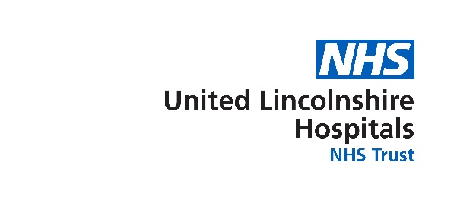

Mobile cancer care unit

In 2014, United Lincolnshire Hospitals NHS Trust
partnered with national cancer charity, Hope for
Tomorrow and launched a mobile cancer care unit
(MCCU) to bring cancer care closer to patients’ homes.

In a unique partnership the MCCU is developed, built, owned and maintained by Hope for Tomorrow and operated by highly trained NHS staff. These well-equipped MCCUs allow cancer patients to receive treatment in a restful environment closer to home, saving stressful long distance travel and minimising waiting times, allowing them to spend more time with their loved ones.

In addition to the MCCU, Hope for Tomorrow provide the Trust with a nurses support vehicle to allow the nurses to travel to and from the daily treatment locations along with any additional supplies or equipment that's required.

The MCCU has historically visited the below locations to give treatments (subject to change):
- Grantham
- Louth
- Skegness

The MCCU can visit up to five locations each week to give treatments, with up to 15 patients benefiting each day. These treatment locations are carefully chosen by the NHS Trust, based on where they can treat the most patients at any given point, hence being subject to change.

For more information about Hope for Tomorrow please click here: www.hopefortomorrow.org.uk

