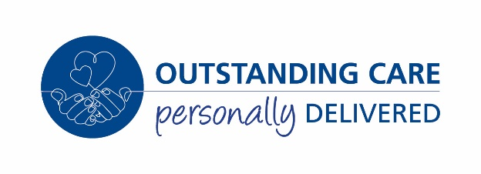

COVID-19 testing for maternity care

Why are we offering you a test?

As a user of our maternity service, you and your partner will be offered a swab test to check whether you are currently carrying the COVID-19 virus, even if you do not have any symptoms.
Recent studies and observations have shown that most pregnant women cope well when exposed to the COVID-19 virus. However, rarely, a pregnant woman can develop severe symptoms of COVID-19 infection during or after giving birth.
When will you be tested?
If you have a planned admission to the Maternity Unit for a caesarean section, you will be offered a swab 72 hours before your admission.
If you are admitted at any other time you will be offered a swab on admission.
How will you get the results?
Results take 24-48 hours to process and you will be contacted by a member of the maternity team once your results have been received.

What are the benefits and implications of the test?

Having the test will mean that you are able to take the necessary precautions to look after your baby and family after your birth.
Will my care change if I test positive?
If you test positive it is recommended that your baby is continuously monitored in labour as the virus is new, as a precaution.
Labouring and birthing in water is not available to women who test positive for COVID-19.
You will be advised to take blood thinning injections for 10 days after your birth to reduce the risk of blood clots.
Do I have to have the test?
It is your choice to have a test. If you decline your care will not change.
What if my birth partner tests positive?
To minimise the risks to staff and other women and families, birth partners who test positive are regretfully unable to attend hospital. You are welcome to bring an alternative partner and we will offer them a test where possible.
Do I need to self-isolate?
The current Public Health England guidelines recommend that everybody maintains social distancing rules.
It is also recommended that if you have a planned admission, for example a planned caesarean birth, that you self-isolate at home for 14 days prior to admission to minimize the chance of exposure.

